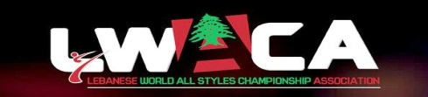
2ND OPEN MEDITERRANEAN ALL MARTIAL ARTS STYLES & traditional SPORT CHAMPIONSHIP
40$ EACH STYLE
LEBANON 19\20\21 may 2017
CHIEF DELEGATION NAME: ----------------------------- TEL: ------------------------- FAX: ------------------
COUNTRY\FED\CLUB:------------------------------------ EMAIL: ----------------------------
Inscription sheet
NAME\last name date of birth PASS PORT No
N.B: PLEASE NOTE THAT THE | LAST DELAY OF INSCRIPTION | WILL BE ON MARCH 31,2017
2ND OPEN MEDITERRANEAN ALL MARTIAL ARTS STYLES & traditional SPORT CHAMPIONSHIP
LEBANON 19\20\21 may 2017 40$ EACH STYLE
Inscription FORM’S sheet
COUNTRY \ FED : ----------------------------- TEL:------------------------- FAX:---------------------- EMAIL:------------------
EMPTY HANDS FORMS WEAPONS FORMS
NAME SOFT STYLE HARD STYLE SOFT STYLE HARD STYLE
N.B: PLEASE NOTE THAT THE LAST DELAY OF INSCRIPTION WILL BE ON MARCH 31, 2017
2ND OPEN MEDITERRANEAN ALL MARTIAL ARTS STYLES & traditional SPORT CHAMPIONSHIP
LEBANON 19\20\21 may 2017 40$ EACH STYLE
Inscription FIGHT’S sheet
COUNTRY \ FED : ----------------------------- TEL:------------------------- FAX:---------------------- EMAIL:------------------
NAME WEIGHT CATEGORY CATEGORY
N.B: PLEASE NOTE THAT THE LAST DELAY OF INSCRIPTION WILL BE ON MARCH 31, 2017
*EACH STYLE MUST CHECK WAC RULES: 40$ EACH STYLE

MANY PRIZES ARE WAITING : BELTS – CERTIFICATE – CUPS- MEDALLES & MORE..
MUAY THAI- TAEKWONDO - JUDO - TUISHO - K1 - MMA
KOWAT AL RAMI & TRADITIONAL SPORT
LEBANESE WAC ASSOCIATION
Bank Account Number
IBAN : ES62 1465 0100 96 1713402304

Registration SUBMIT:
secretaria@deamydc.es

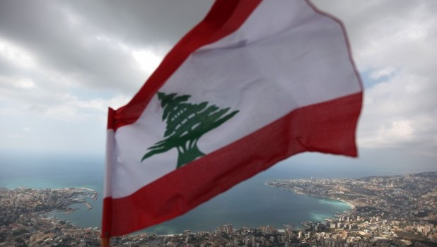
CHIEF DELEGATION SIGNATURE: -----------------------------------------

